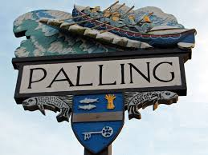
SEA PALLING & WAXHAM PARISH COUNCIL MEETING
REMOTE MEETING BY ZOOM
22nd June 6.30pm 2020

Attendees: K Matthews (Chairman), J Cocker (Vice Chairman), S Deary, G Casson.
In attendance; Patsy Adams (Clerk)

All minutes are draft until approved at a subsequent meeting

www.seapallingpc.norfolkparishes.gov.uk
The Chairman welcomed the members to the Parish Council Zoom Meeting.
The Meeting began at 6.30pm

- APOLOGIES FOR ABSENCE Apologies: None
- Declarations of interest and requests for dispensations None
- PUBLIC PARTICIPATION. The public participation session lasts for 10 minutes. No members of the public attended the meeting.

- TO AGREE THAT THE COUNCIL MEETS THE CRITERIA TO SUBMIT AN EXEMPTION CERTIFICATE AND TO PROPOSE A RESOLUTION TO DECLARE THE PARISH COUNCIL EXEMPT FROM SUBMITTING A LIMITED ASSURANCE REVIEW. On a proposal by Cllr Casson members agreed that they Parish Council did meet the criteria to submit an exemption and instructed the Clerk accordingly.
- The date of the next meeting: 21st July 2020 at 6.30pm. The meeting will be held remotely unless circumstances change.

TO CLOSE THE MEETING There being no further business the Chairman closed the meeting at
6.50 pm

