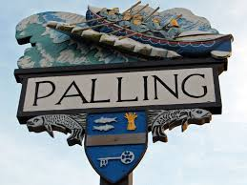
SEA PALLING & WAXHAM
ANNUAL PARISH MEETING
MINUTES
18th May 2021
The Village Hall, Sea Palling

Attendees: K Matthews (Chairman), J Cocker (Vice-Chairman) S Deary, M Vacca and G Casson.
In attendance: Patsy Adams (Clerk) One Member of the public
www.seapallingpc.norfolkparishes.gov.uk
All minutes are draft until approved at a subsequent meeting

The meeting began at 7.00pm

- WELCOME FROM THE CHAIRMAN OF SEA PALLING PARISH COUNCIL. The Chairman welcomed everyone and thanked them for attending.

- APOLOGIES FOR ABSENCE. Cllr J Crafer
- THE CHAIRMAN’S REPORT. The Chairman had previously circulated a report.
- *COMMUNITY REPORTS. Due the current situation no community or councillor reports had been requested but District Councillor Blathwayt and Cllr Vacca in her capacity as Church Warden did submit reports and these were gratefully received.

- ELECTORS QUESTIONS TO THE COUNCILLORS. None
The meeting closed at 7.04pm.

