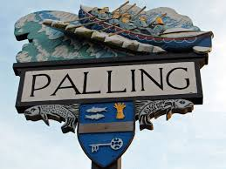
SEA PALLING & WAXHAM PARISH COUNCIL EXTRAORDINARY MEETING MINUTES
24th January at 7pm 2022
Sea Palling Village Hall

www.seapallingpc.norfolkparishes.gov.uk
Attendees : K Matthews (Chairman), J Cocker, S Burrell, S Deary, G Casson, J Crafer.
In attendance: Patsy Adams (Clerk)
The Meeting began at 7pm

- APOLOGIES FOR ABSENCE. M Vacca
- DECLARATIONS OF INTEREST AND REQUESTS FOR DISPENSATIONS. None
- TO CONSIDER THE BUDGET PROPOSALS FOR 2022/23 AND AGREE THE PRECEPT. Members considered documents previously circulated and agreed to request a precept of £13,908.00

- To close the meeting. There being no further business, the Chairman closed the meeting at 7.10pm

