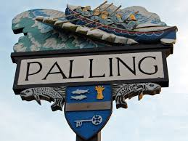
SEA PALLING & WAXHAM PARISH COUNCIL MEETING
AGENDA
19th April 2022 at 7pm
Sea Palling Village Hall

www.seapallingpc.norfolkparishes.gov.uk
Members of the Parish Council you are summoned to attend the meeting of Sea Palling and Waxham Parish Council to be held at the Village Hall, Sea Palling at 7pm on 19th April 2022
Patsy Adams
11/04/22

- APOLOGIES FOR ABSENCE
- DECLARATIONS OF INTEREST AND REQUESTS FOR DISPENSATIONS
- PUBLIC PARTICIPATION – Restricted to 2 minutes per person.

- TO APPROVE THE MINUTES OF THE MEETING HELD ON 22nd March 2022

- COUNTY & DISTRICT COUNCILLOR and POLICE REPORTS
- County Councillor
- District Councillor
- Police Reports if available

- FINANCE and GOVERNANCE
- To conform receipt of the Annual Governance and Accountability Return

- UPDATE ON THE ABORTIVE COSTS AGREEMENT The Abortive Costs Agreement (Beach Road)
- TO RECEIVE AN UPDATE FROM THE CHAIRMAN PARKING AND TREE PLANTING ON WAXHAM ROAD
- NEW ITEMS and CORRESPONDENCE – The Off-Street Parking Places and Civil Enforcement Order – public consultation begins on the 22nd April

- PLANNING - To receive an update and consider further applications received.
- ITEMS FOR THE NEXT AGENDA
- DATE OF THE NEXT MEETING 24th May 2022
- TO CLOSE the MEETING

