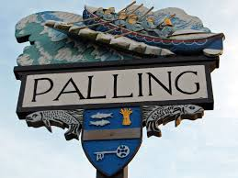
SEA PALLING & WAXHAM ANNUAL PARISH MEETING
MINUTES
24th MAY 2022
Sea Palling Village Hall

www.seapallingpc.norfolkparishes.gov.uk
Attendees: K Matthews (Chairman) J Cocker (Vice Chairman) Cllrs: S Burrell, M Vacca, S Deary
In attendance: Patsy Adams (Clerk). H Blathwayt (District Councillor). Three members of the public.

- WELCOME FROM THE CHAIRMAN The Chairman opened the meeting at 7pm and welcomed everyone.
- APOLOGIES FOR ABSENCE. Apologies received from Cllr Casson and Cllr Crafer
- THE CHAIRMAN’S REPORT The Chairman read his annual report.
- COMMUNITY REPORTS The Chairman read the report received from the Community Trust. Rhena Branch read the Church Report and Barry Halliday read the Village Hall report
- ELECTORS QUESTIONS TO THE COUNCILLORS No questions received.

There being no further business the Chairman closed the Annual Pariah Meeting at 7.15pm. The Annual Parish Council Meeting followed immediately afterwards

