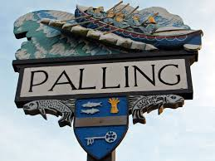
SEA PALLING & WAXHAM ANNUAL PARISH MEETING
AGENDA
TUESDAY 15TH APRIL 2025
Sea Palling Village Hall
6PM

www.seapallingpc.norfolkparishes.gov.uk

SEA PALLING AND WAXHAM PARISH COUNCIL

NOTICE is hereby given that the Annual Meeting of Electors of the Civil Parish of Sea Palling and Waxham will be held in Sea Palling Village Hall, Waxham Road, Sea Palling, on Tuesday 15th April 2025 at 6pm.

All electors of the Parish are cordially invited.

AGENDA

1 Welcome and Confirmation of the Minutes of the Last Meeting.

2 Annual Report of the Parish Council.

3 Reports from other organisations.

4 Open Forum.

5. Close.

By Order of the Chair, Mrs Val Bird

