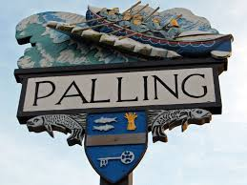
SEA PALLING & WAXHAM ANNUAL PARISH MEETING
AGENDA
25TH MAY 2024
Sea Palling Village Hall
10 am

www.seapallingpc.norfolkparishes.gov.uk

MEMBERS OF THE PARISH AND THE PRESS ARE INVITED TO ATTEND THE ANNUAL PARISH MEETING. IF YOU WISH TO RECORD THE MEETING, PLEASE INFORM THE CLERK BEFORE THE MEETING BEGINS.

MEMBERS – YOU ARE SUMMONED TO ATTEND THE ANNUAL MEETING OF THE PARISH.

K Matthews
CHAIRMAN
20/05/24

- WELCOME FROM THE CHAIRMAN OF SEA PALLING & WAXHAM PARISH COUNCIL.

- APOLOGIES FOR ABSENCE
- THE CHAIRMAN’S REPORT.
- ELECTORS QUESTIONS TO THE COUNTY & DISTRICT COUNCILLORS.

