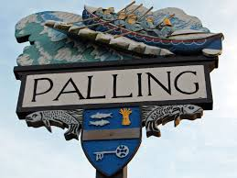
SEA PALLING & WAXHAM ANNUAL PARISH MEETING
AGENDA
25TH MAY 2023
Sea Palling Village Hall
7pm

www.seapallingpc.norfolkparishes.gov.uk
CONTACT THE CLERK – 07506 481841 clerkseapallingpc@gmail.com

MEMBERS OF THE PARISH AND THE PRESS ARE INVITED TO ATTEND THE ANNUAL PARISH MEETING. IF YOU WISH TO RECORD THE MEETING, PLEASE INFORM THE CLERK BEFORE THE MEETING BEGINS.

MEMBERS – YOU ARE SUMMONED TO ATTEND THE ANNUAL MEETING OF THE PARISH.

K Matthews
CHAIRMAN
29/04/23

- WELCOME FROM THE CHAIRMAN OF SEA PALLING & WAXHAM PARISH COUNCIL.

- APOLOGIES FOR ABSENCE
- THE CHAIRMAN’S REPORT.
- COUNCILLOR REPORTS
- COMMUNITY REPORTS

- ELECTORS QUESTIONS TO THE COUNCILLORS.

